2023 Aquatic Area Envirothon Questions
1.) Water clarity can indicate problems associated with excess nutrients or soil erosion. What tool do biologists use the check water clarity?
- Eckman dredge
- Flow meter
- Secchi disk
- Meter stick
2.) What combination of fish species is typically the most successful in Ohio farm ponds?
- Channel catfish, white crappie, and green sunfish
- Largemouth bass, bluegill, and channel catfish
- Smallmouth bass, bluegill, and channel catfish
- Walleye, yellow perch, and emerald shiners
3.) The stream running through this field is part of a network of many streams and rivers all leading to one place. What is this geographic feature on a landscape called?
  - Watershed
  - Channel
  - Riparian Area
  - Point source

4.) Of the four variables listed below, which one is NOT used in wetland delineation or determining if a site is a wetland?
    - Topography
    - Vegetation type
    - Hydrology
    - Soil type

5.) Harmful algal blooms are caused by _________
  - Green algae
  - Red Algae
  - Cyanobacteria
  - Chlorophyll
6.) This wetland tree often develops specialized root structures called pneumatophores, or knees, when growing in flooded soil.
  - Eastern Cottonwood
  - Bald Cypress
  - American Sycamore
  - All the above
7.) Wetlands are important parts of a healthy, functioning ecosystem. In addition to providing valuable wildlife habitat, what important function does a wetland provide?
- Converts oxygen to carbon dioxide
- Transports nutrients from trees to vegetation
- Filters and stores water, releasing it slowly after a rain event
- None of the above
8.) A small intermittent stream at the headwaters of drainage network is classified as what order using the Strahler Stream Order Classification System?
  - Tenth
  - Antecedent
  - Braided
  - First
9.) As a watershed is developed from agriculture/forest to more urban/industrial, what is the most significant impact to the streams and rivers?
  - Greater amount of impervious surfaces resulting in larger flood events
  - More debris in the water resulting in more flooding conditions.
  - More drainage tile in the watershed, resulting in greater flood events.
  - Less surface runoff because urban environments slow water flow

10.) The process in which lakes and reservoirs separate into three distinct layers (epilimnion, thermocline, and hypolimnion) is called?
- Turn-over
- Stratification
- Layering
- Buffering

11.) Dissolved oxygen refers to the concentration of oxygen gas incorporated in water. Which of the following is not a pathway for oxygen to enter the water?
- Fish respiration
- Absorption from the atmosphere
- Photosynthesis
- Turbulence from current, wind, or waves

12.) The absence of sensitive species of fish or aquatic invertebrates is indicative of a stream that is:
- Healthy
- Impaired
- Unnatural
- Unmanaged

13.) Streams that are deemed high quality have a greater proportion of aquatic species that are sensitive to poor water quality. Which of the following invertebrates is not considered sensitive?
- Caddisflies
- Riffle beetles
- Midge flies
- Stoneflies

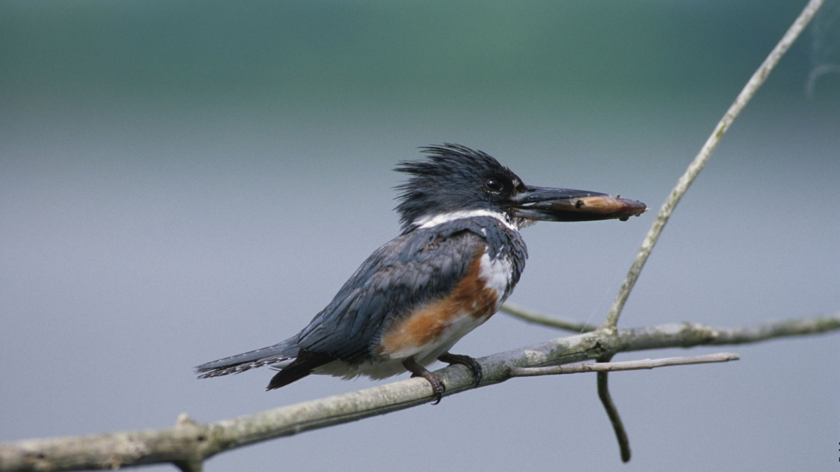
14.) Many birds may be found along or in Ohio’s waterways. Some prey on aquatic creatures, while others eat aquatic vegetation. Below is a picture of the former, preying mainly on small fish. Identify the bird.
- Hairy Woodpecker
- Green Heron
- Belted Kingfisher
- Pied-billed Grebe

15.) Water quality is one factor that determines what species may be found in a body of water. However, there are other factors that may prevent certain species from occurring. In a warm water quality stream, which of the following would you least expect to find?
- Smallmouth Bass
- Muskellunge
- Brook Trout
- Brindled Madtom

16.) Soil particles running into waterways can cause many issues. When these soil particles enter a stream and build up along the bottom, covering the crevices of rocks and other debris, it is called:
- Eutrophication
- Sedimentation
- Suffocation
- Percolation

17.) Many species of trees can be found in riparian zones along waterways. Some trees are better adapted to the challenges faced by those along waterways. Which of the following trees would be considered the most water tolerant species?
- Sycamore
- White Pine
- Black Cherry
- Black Walnut

18.) Various gears can be used to collect fish from our waterways. If you were trying to find live specimens from a riffle, which piece of equipment would BEST be suited for this?
- Seine
- Bucket
- Live-well
- Electrofishing boat

19.) Cyanobacteria are classified as:
- Algae
- Plant
- Protists
- None of the above

20.) Correctly identify the macroinvertebrate below:
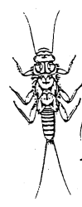
- Mayfly
- Damselfly
- Stonefly
- Dragonfly

21.) Indicator species help us identify waterways that may or may not be contaminated. Amphibians are a great indicator to show the quality of a body of water, but many are in decline. One such species is North America’s largest salamander, pictured below. Correctly identify the species.
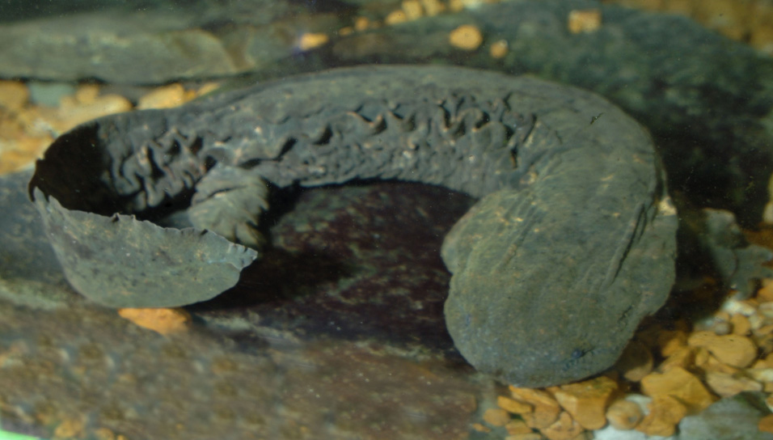
- Common Mudpuppy
- Cave Salamander
- Eastern Hellbender
- Four-toed Salamander

22.) Vernal pools provide excellent habitat for many species of amphibians rear their offspring. This is because vernal pools:
- Have an abundance of food
- Have excellent water quality
- Lack the predators found in many permanent waterways
- Tend to have cooler temperatures

23.) This non-native species of fish can be found in water bodies all over Ohio and is one of the largest members of the minnow family.

- Channel catfish
- Bluntnose minnow
- Spotted Sucker
- Common Carp

24.) Which of these systems would not be considered lentic feature:

- Lake
- Pond
- Marsh
- Stream

25.) Whetstone Creek runs through the back of this property. This stream is part of what watershed?

- Olentangy River
- Ohio River
- Mississippi River
- All the above

26.) A barrier of permanent vegetation, either forest or other vegetation, between waterways and land uses such as agriculture or urban development, designed to interrupt and filter out pollution before it reaches the surface water resource is known as a:

- Buffer strip
- Canopy
- Catchment
- Floodplain

27.) This frog is the largest species in Ohio and typically breeds later in the season (May-July). You can often hear males with their deep, jug-o’-rum call at night at ponds like this around the state.

- Green Frog
- Leopard Frog
- Gray Tree Frog
- American Bullfrog

